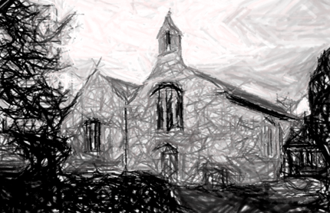
Eglwys Sant Asa
St Asaph Parish Church

The Consecration of the New Altars

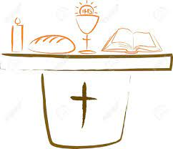

Sunday 26th June 2022

Celebrant & Preacher:
The Right Rev’d Gregory Cameron

Llywydd a Phegethwr:
Y Gwir Barch. Gregory Cameron

Emyn Hymn

God is here! As we your people
Meet to offer praise and prayer,
May we find in fuller measure
What it is in Christ we share.
Here, as in the world around us,
All our varied skills and arts
Wait the coming of the Spirit
Into open minds and hearts.

Here are symbols to remind us
Of our lifelong need of grace;
Here are table, font and pulpit;
Here the cross has central place.
Here in honesty of preaching,
Here in silence, as in speech,
here, in newness and renewal,
God the Spirit comes to each.

Here our children find a welcome
In the Shepherd’s flock and fold;
Here as bread and wine are taken,
Christ sustains us as of old.
Here the servants of the Servant
Seek in worship to explore
What it means in daily living
To believe and to adore.

Lord of all, of church and kingdom,
In an age of change and doubt,
Keep us faithful to the Gospel;
help us work your purpose out.
Here, in this day’s dedication,
All we have to give, receive;
We, who cannot live without you,
We adore you! We believe!
Fred Pratt Green 1903-200
Tune: Blaenwern

Yn enw’r Tad, a’r Mab, a’r Ysbryd Glân. Amen.

Grace and peace be with you
and keep you in the love of Christ.

The Bishop offers words of welcome and introduction and calls the people to penitence.

Silence

Lord Jesus, you call all who are thirsty to come and drink of the water of life.
Lord, have mercy: Lord, have mercy.

Lord Jesus, from your heart flows streams of living water.
Christ, have mercy: Christ, have mercy.

Lord Jesus, we have been brought to life and raised up with you.
Lord, have mercy: Lord, have mercy.

Yr hollalluog Dduw a drugarhao wrthych, Almighty God have mercy on you,
maddau ichwi a’ch rhyddhau o bechod, forgive you and set you free from sin,
a’ch cadw yn y bywyd tragwyddol. and keep you in eternal life.
Amen. Amen.

Gloria in Excelsis

Glory be to God in heaven,
and to all on earth, his peace;
Lord and Father, King in glory,
gifts of praise in us release,
so our worship and thanksgiving
from our hearts will never cease.

Christ incarnate, sent by Father
to redeem, renew, restore;
risen Lamb, in glory seated,
hear our prayers, Lord, we implore.
Now to Father, Son, and Spirit
be all glory evermore.
Words: John Richards
Tune: Regent Square

The Collect - Please remain Standing

Silence

Almighty God,
to whose glory we celebrate the dedication
of this house of prayer:
we praise you for the many blessings
you have given to those who worship you here;
we pray that all who seek you in this place may find you,
and, being filled with the Holy Spirit,
become a living temple acceptable to you;
through Jesus Christ your Son our Lord,
who is alive and reigns with you,
in the unity of the Holy Spirit,
one God, now and for ever. Amen.

Ephesians 2. 19-22
Please Sit
A reading from the letter of Paul to the Ephesians.

So then you are no longer strangers and aliens, but you are citizens with the saints and also members of the household of God, built upon the foundation of the apostles and prophets, with Christ Jesus himself as the cornerstone. In him the whole structure is joined together and grows into a holy temple in the Lord; in whom you also are built together spiritually into a dwelling-place for God.

For the word of the Lord:
thanks be to God.

The Gospel John 2. 13-22
Please Stand
Alleluia, alleluia, give thanks to the risen Lord,
Alleluia, alleluia, give praise to his name.

Spread the good news o’er all the earth:
Jesus has died and has risen.

Alleluia, alleluia, give thanks to the risen Lord,
Alleluia, alleluia, give praise to his name.
Donald Fishel b.1950
The Lord be with you:
and also with you.

Listen to the Gospel of Christ according to Saint John.
Glory to you, O Lord.

The Passover of the Jews was near, and Jesus went up to Jerusalem. In the temple he found people selling cattle, sheep, and doves, and the money-changers seated at their tables. Making a whip of cords, he drove all of them out of the temple, both the sheep and the cattle. He also poured out the coins of the money-changers and overturned their tables. He told those who were selling the doves, ‘Take these things out of here! Stop making my Father’s house a market-place!’ His disciples remembered that it was written, ‘Zeal for your house will consume me.’ The Jews then said to him, ‘What sign can you show us for doing this?’ Jesus answered them, ‘Destroy this temple, and in three days I will raise it up.’ The Jews then said, ‘This temple has been under construction for forty-six years, and will you raise it up in three days?’ But he was speaking of the temple of his body. After he was raised from the dead, his disciples remembered that he had said this; and they believed the scripture and the word that Jesus had spoken.

This is the Gospel of the Lord:
Praise to you, O Christ.

Alleluia, alleluia, give thanks to the risen Lord,
Alleluia, alleluia, give praise to his name.

The Sermon – The Bishop of St Asaph Please Sit

The Affirmation of Faith Please Stand

A Baptismal Creed
I believe and trust in God the Father,
who created all that is.

I believe and trust in his Son Jesus Christ,
who redeemed humankind.

I believe and trust in his Holy Spirit,
who gives life to the people of God.

I believe and trust in one God,
Father, Son and Holy Spirit. Amen.

The Intercession Please Sit

This response is used
Lord, in your mercy:
hear our prayer.

At the end
Merciful Father,
accept these prayers
for the sake of your Son,
our Saviour Jesus Christ. Amen.

The Peace Please Stand

The risen Christ said, Peace be with you! As the Father sent me so I send you. Then he breathed on them saying, Receive the Holy Spirit.

Tangnefedd yr Arglwydd a fo gyda chwi bob amser.
The peace of the Lord with you always.
And also with you.

Let us offer one another a sign of the Lord’s peace.

The Consecration of the Altars

The following is used at each altar and they are anointed with the Oil of Chrism

God you are good:
Your love is everlasting!

Blessed are you loving God,
for you show us the meaning of love
through the sacrifice of your Son, Jesus our Lord.
Consecrate this Altar,
that as your people gather here to join
with the worship of heaven,
they may know your forgiveness,
be refreshed and sustained the presence of Christ
in bread and wine,
and united with one another,
they may be strengthened
for service in the world.
Blessed be God, Father, Son and Holy Spirit.
Blessed be God for ever.

After the consecration of the Altar, it is dressed and prepared for the Eucharist
while the following hymn is sung

I, the Lord of sea and sky, I have heard my people cry.
All who dwell in dark and sin my hand will save.
I who made the stars of night, I will make their darkness bright.
Who will bear my light to them? Whom shall I send?

Here I am, Lord. Is it I, Lord?
I have heard you calling in the night.
I will go, Lord, if you lead me.
I will hold your people in my heart.

I, the Lord of snow and rain, I have borne my people’s pain.
I have wept for love of them. They turn away.
I will break their hearts of stone, give them hearts for love alone.
I will speak my word to them. Whom shall I send?

I, the Lord of wind and flame, I will tend the poor and lame.
I will set a feast for them. My hand will save.
Finest bread I will provide till their hearts be satisfied.
I will give my life to them. Whom shall I send?
Daniel L. Schutte b.1947
Tune: Here I am, Lord

The Thanksgiving

We celebrate together the gifts and grace of God.
We take this bread,
we take this wine
to follow Christ’s example
and obey his command.

Father, you have appointed our Lord Jesus Christ
as mediator of a new covenant:
give us grace to draw near with fullness of faith
and join ourselves in a perpetual covenant with you;
through Jesus Christ our Lord. Amen.

The Eucharistic Prayer

The Lord be with you.
And also with you.

Lift up your hearts.
We lift them to the Lord.

Let us give thanks to the Lord our God.
It is right to give our thanks and praise.

It is indeed right, it is our duty and our joy
at all times and in all places to give you thanks, holy Father,
all-powerful and everliving God,
through Jesus Christ our Lord.

Who, seated at table with his apostles,
offered himself to you,
the acceptable and perfect gift.
As we gather around this table
to be nurtured and sustained with holy food,
we share in the memorial of his suffering and death
and in the fullness of his saving power.

And so with the hosts of angels and all the company of heaven
we proclaim the glory of your name
and join in their unending hymn of praise:

Holy, holy, holy, holy,
Holy, holy, Lord God Almighty.
And we lift our hearts before you
as a token of our love.
Holy, holy, holy, holy.

Gracious Father, gracious Father,
Blessed is the one who comes to us
in your name.
And we lift our hearts before you
as we give you thanks and praise.
Hosanna in the highest.

Words & Music: Jimmy Owens

All praise and thanks to you, true and living God,
Creator of all things, Giver of life.
You formed us in your own image;
but we have marred that image and fall short of your glory.
We give you thanks
that you sent your Son to share our life;
you gave him up to death that the world might be saved,
and you raised him from the dead
that we might live in him and he in us.

Sanctify with your Spirit this bread and wine, your gifts to us,
that they may be for us the body and blood of our Saviour Jesus Christ.

On the night he was betrayed, he took bread,
and when he had given thanks
he broke it and gave it to his disciples, saying,

Take, eat; this is my body which is given for you:
do this in remembrance of me.

In the same way after supper he took the cup,
and when he had given thanks
he gave it to them, saying,

Drink from this, all of you,
for this is my blood of the new covenant
which is shed for you and for many
for the forgiveness of sins:
do this as often as you drink it
in remembrance of me.

Let us proclaim the mystery of faith:
Christ has died.
Christ is risen.
Christ will come in glory.

As he has commanded us, Father,
we remember Jesus Christ, your Son.
Proclaiming his victorious death,
rejoicing in his resurrection
and waiting for him to come in glory
we bring to you this bread, this cup.

Accept our sacrifice of thanks and praise.
Restore and revive your people,
renew us and all for whom we pray
with your grace and heavenly blessing,
and at the last receive us with all your saints
into that unending joy promised by your Son, Jesus Christ our Lord.

Through him, with him, in him,
in the unity of the Holy Spirit
all honour and glory are yours, almighty Father,
for ever and ever. Amen.

Please Sit
Silence is kept

Let us pray with confidence to the Father:

Our Father in heaven,
hallowed be your name,
your kingdom come,
your will be done,
on earth as in heaven.
Give us today our daily bread,
forgive us our sins
as we forgive those
who sin against us.
Save us from the time of trial
and deliver us from evil.

For the kingdom, the power
and the glory are yours,
now and for ever. Amen.

The Communion

The Bishop breaks the bread
We break this bread to share in the body of Christ.
Though we are many, we are one body
for we all share in one bread.

We sing
Jesus, Lamb of God we pray you
show your mercy on us here.
You who take our sins upon you
show your mercy we implore.
Lord, redeemer of this world
grant your peace O Lord we pray.
Jesus, Lamb of God we call you –
show your mercy here today.
Tune: Hyfrydol

The Invitation to Holy Communion

Jesus is the Lamb of God
who takes away the sins of the world.
Happy are those who are called to his supper.
Lord, I am not worthy to receive you,
but only say the word and I shall be healed.

All those who are baptised and would normally receive holy communion in any Christian Church are welcome to receive today. Baptised children are welcome receive holy communion at the discretion of their parents. If you are not receiving you are welcome to come forward for a blessing but please bring this leaflet with you as a signal to the clergy.

The Host is administered with the following words

The Body of Christ. Amen.

At the end of Communion, we sing

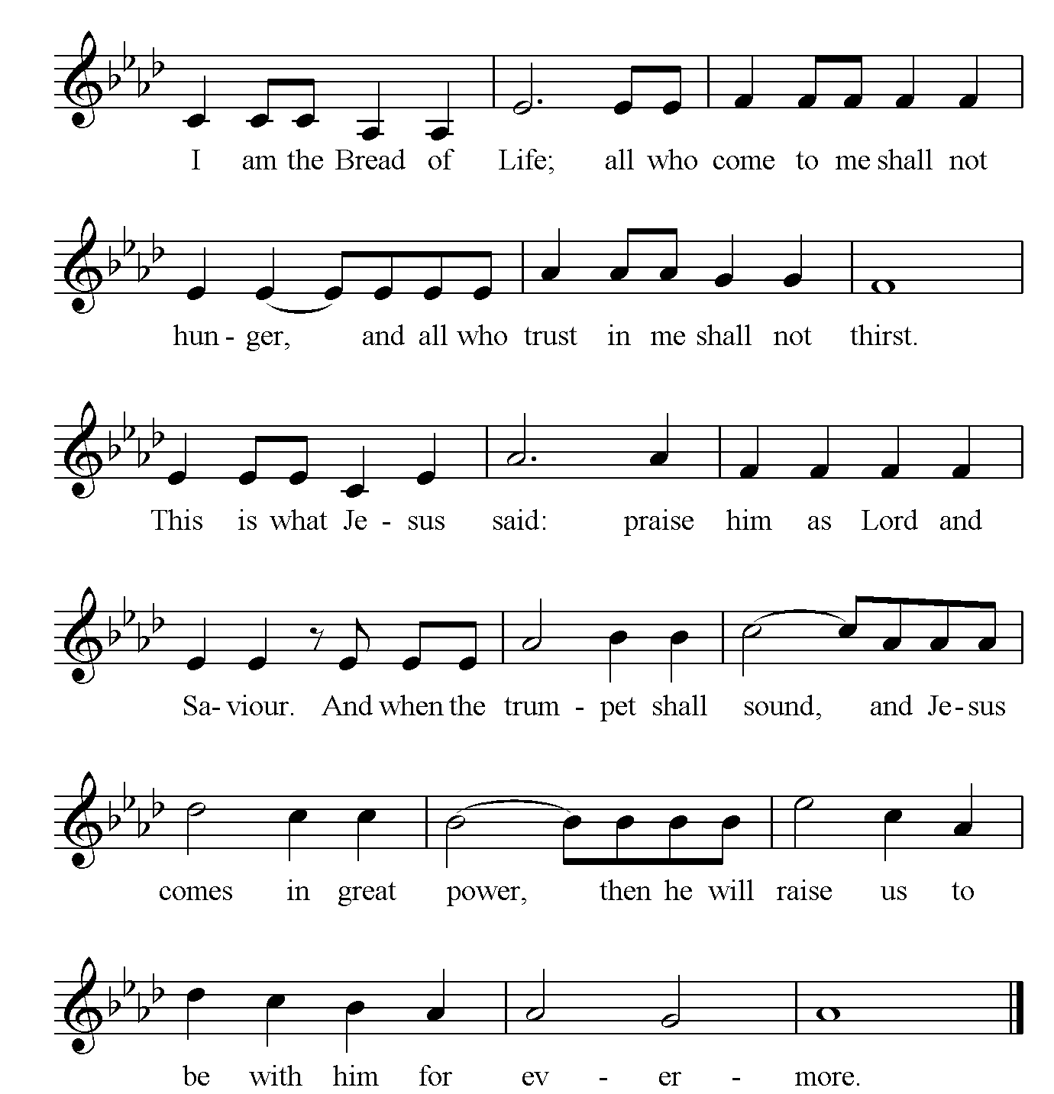

Silence is kept

The Sending Out Please Stand

Diolchwch i’r Arglwydd, oherwydd graslon yw ef:
Give thanks to the Lord for he is gracious:
his love is everlasting.

Father in heaven,
grant that we, fed with the living bread of heaven,
and united in the body of your Son,
may be the temple of your presence,
the place of your glory on earth,
and a sign of your redeeming grace;
through Jesus Christ our Lord. Amen.

The Commissioning of the People

We have received Jesus in Word and Sacrament
and have been strengthened by the reminder of
God’s constant presence in our lives through the Holy Spirit,
so let us rededicate ourselves to his service.

God our Father, through his Son Jesus Christ,
and in the power of the Holy Spirit,
sends us out into the world to build his Kingdom.
Therefore, I ask:

Empowered by the Holy Spirit, will you walk into God’s future,
trusting him to be your guide?
With the help of God, we will.

Will you go out and pray for one another and for this community
until your hearts beat with the longings of God?
With the help of God, we will.

Will you go out and carry the light and hope of Christ into the world?
With the help of God, we will.

Will you go out and stand with those who are hurt and broken?
With the help of God, we will.

Will you go out and play your part in the building up of God’s Kingdom?
With the help of God, we will.

God of Mission,
who alone brings growth to your Church,
send your Holy Spirit to give
vision to our planning,
wisdom to our actions,
joy to our worship,
and power to our witness.
Help our church to grow in numbers,
in spiritual commitment to you,
and in service to our local community,
through Jesus Christ our Lord. Amen.

The Blessing

The Lord be with you
and also with you.

Bishop Gregory gives the Blessing

Go in peace to love and serve the Lord.
In the name of Christ. Amen.

Final Hymn

We have a gospel to proclaim,
good for all throughout the earth;
the gospel of a Saviour’s name:
we sing his glory, tell his worth.

Tell of his birth and Bethlehem
not in a royal house or hall
but in a stable dark and dim,
the Word made flesh, a light for all.

Tell of his death at Calvary,
hated by those he came to save,
in lonely suffering on the Cross;
for all he loved his life he gave.

Tell of that glorious Easter morn:
empty the tomb, for he was free.
He broke the power of death and hell
that we might share his victory.

Tell of his reign at God’s right hand,
by all creation glorified.
He sends his Spirit on his Church
to live for him, the Lamb who died.

Now we rejoice to name him King:
Jesus is Lord of all the earth.
This gospel-message we proclaim:
we sing his glory, tell his worth.
Edward Joseph Burns b. 1938
Tune: Fulda

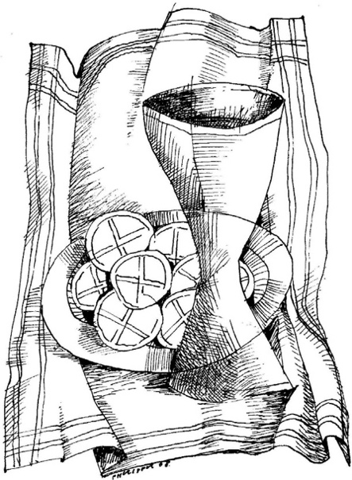

An Order for the Holy Eucharist 2004, material from which is included in this service is copyright © Church in Wales Publications 2004.

Other texts are reproduced under CCL licence number 961722.

Notices

Early Eucharist. A reminder that the 8am Eucharist now takes place again on the first Sunday of each month. The next one will be on 3rd July.

Evensong. Choral Evensong takes place at the Cathedral on Fridays at 6pm and Sundays at 3.30pm in term time. A beautiful service with beautiful music and a lovely end to the day. Why not give it a try? It would be good to see you there.

Daily Prayer. Can you be a part of the daily prayer life of this place? Please see leaflet on the Prayer and Spirituality table in the south transept of the Cathedral.

Churchyard work party on Saturday, July 9th, 10am -12 at the Parish Church. Refreshments provided.
All help appreciated.

Peace Doves. Our peace doves are now flying! Please do come and admire the beautiful Peace Tree by the high altar in the cathedral and say a prayer there. Warmest thanks to Kate and Frank Jordan for helping us make the doves and for creating the tree. If you would still like to add your own message, please take a dove from the Ukraine prayer station in the south transept and leave it in the basket. New doves will be added to the tree in batches.

The Week Ahead

27th Monday – Feria
9am Morning Prayer
9.30am Holy Eucharist at the Cathedral
5pm Evening Prayer

28th Tuesday – Irenaeus, Bishop &
Doctor
9am Morning Prayer
6pm Evening Prayer
7pm Holy Eucharist at the Cathedral

29th Wednesday – Peter & Paul,
Apostles
9am Morning Prayer
10.30am Holy Eucharist at the Cathedral
5pm Evening Prayer

30th Thursday – The Martyrdom of
Paul, Apostle
9am Morning Prayer
10am Holy Eucharist at the Parish Church
5pm Evening Prayer

1st Friday – Euddogwy, Bishop
9am Morning Prayer
9.30am Offeren (Welsh Eucharist)
6pm Choral Evensong

2nd Saturday – Feria
8am Morning Prayer
10am Ordination of Deacons
5pm Evening Prayer

3rd Sunday – Thomas, Apostle
8am Holy Eucharist
9.30am The Parish Eucharist
11am The Cathedral Eucharist
3.30pm Choral Evensong

Contact:
Parish Church: 01745 535957
Fr Rex: 07393 639813

Parish Church Website: www.stasaphparishchurch.org.uk

